Berkeley Savage

CS 3700

Doctor Cantrell

10/20/2020

GitHub Lab Screenshots

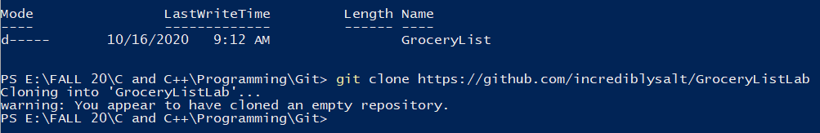PowerShell window cloning repository onto the computer.

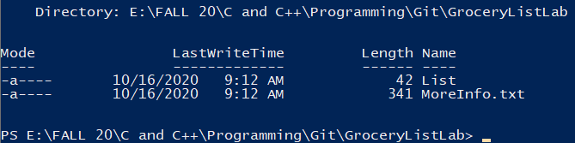PowerShell window showing all items have been successfully cloned.

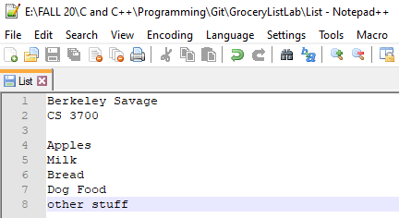Notepad++ window, editing the Grocery List to include name and class.

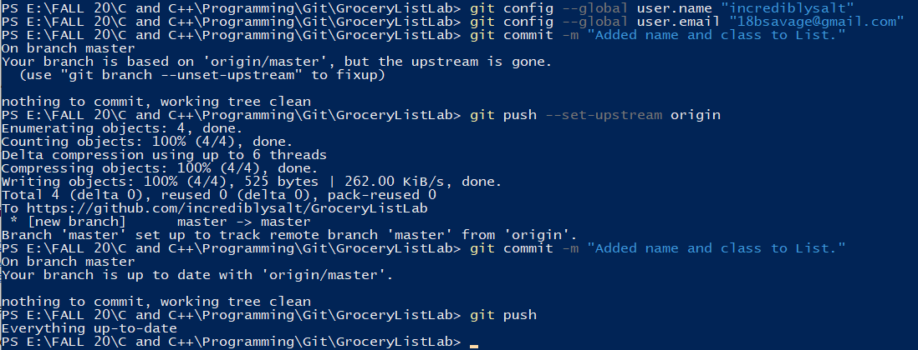Pushing the list changes to the master branch on GitHub repository.

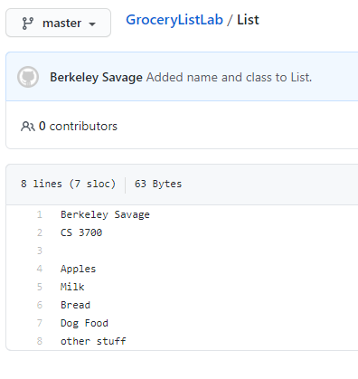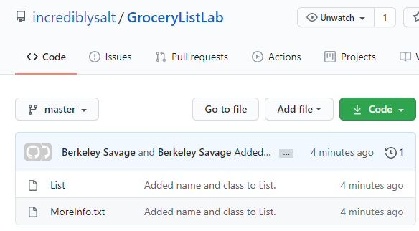Changes to the master branch on the online repository.

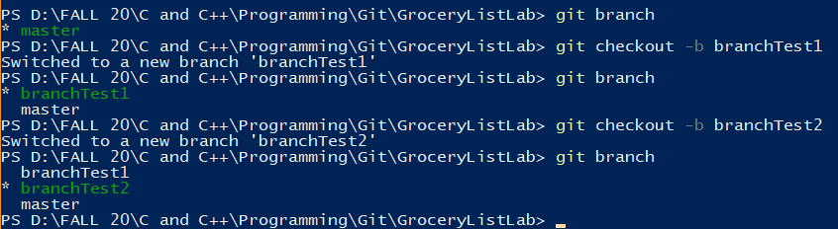Adding new branches, branchTest1 and branchTest2.

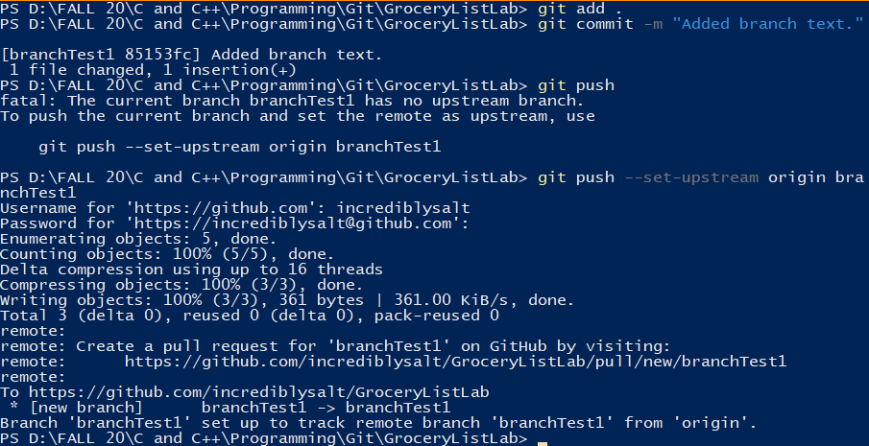Committing changes on branchTest1 to online repository.

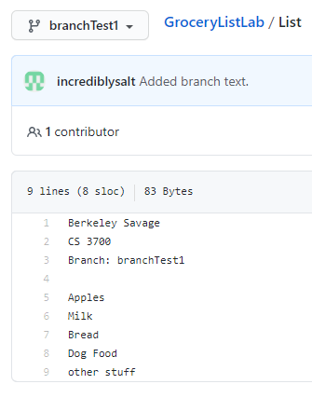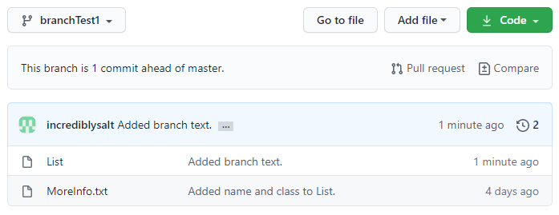Changes on branch branchTest1 on online repository.

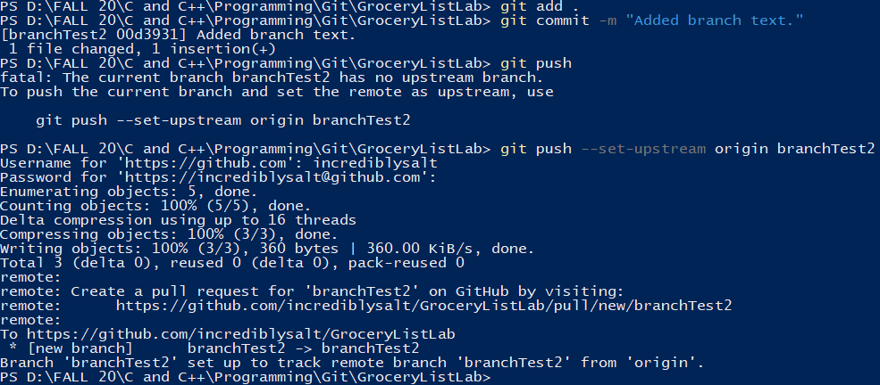Committing changes on branchTest2 to online repository.

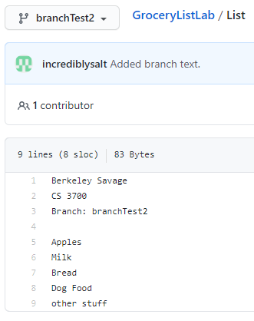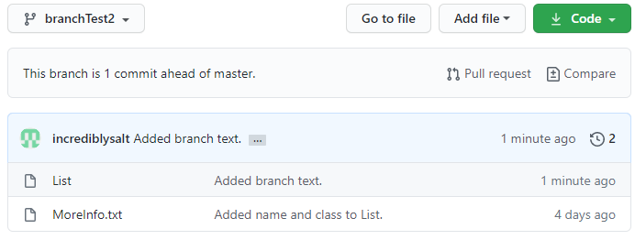Changes on branch branchTest2 on online repository.